Opening Pathways: Skills, Practice, and Mentorship in Open Source.
A survey report

Introduction
Open source software (OSS) is a critical component of modern bioinformatics, supporting reproducible research, scalable data analysis, and collaborative tool development. Many widely used bioinformatics tools—including workflow managers, statistical packages, and sequence analysis software—are developed and maintained as open source projects. As a result, the ability to use and contribute to OSS has become an increasingly important skill for researchers and students working in computational biology and related disciplines.
OSS development also plays an important role in capacity building. Participation in open source projects allows learners to gain practical programming experience, develop collaborative skills, and build professional portfolios. These benefits are particularly important in regions where access to formal software engineering training may be limited.
At the Bioinformatics Hub of Kenya (BHKi), we recognize that OSS is essential not only for scientific progress but also for strengthening collaboration, skills development, and innovation within the local and regional bioinformatics community. To better understand the current landscape of OSS engagement in our small bioinformatics community in Kenya, we conducted a community survey. The findings provide insight into awareness, technical skills, perceived barriers, and opportunities for growth.

Motivation
While certain aspects of the Open Science umbrella, such as open access publishing and open data sharing, have gained increasing recognition within the life sciences research communities in Kenya, engagement with open source software remains comparatively limited. There is engagement in the computer science and IT sectors, but limited in the life science sectors. This may be because the pure computational and life science communities rarely meet in the same spaces. However, many researchers write code as part of their work and express interest in contributing to OSS projects, considering it as a career path, but often lack structured opportunities, mentorship, and training pathways.
Previous studies have shown that participation in open source communities is strongly influenced by access to mentorship, clear onboarding pathways, and opportunities for hands-on practice. Without these supports, many potential contributors remain passive users of open tools rather than active participants in development.
This survey aimed to identify:
- Current levels of awareness and participation in OSS
- Technical skills and experience within the community
- Barriers preventing individuals from contributing
- Types of support and training that would enable participation
Guided by BHKi’s “by the community, for the community” philosophy, the goal was to ensure that future initiatives are informed directly by community needs and priorities.

Survey Results

Demographics
Participants represented a diverse range of academic and professional backgrounds. The majority of respondents were students, particularly at the undergraduate and master’s levels. This reflects the growing integration of bioinformatics and computational methods into university training programs.
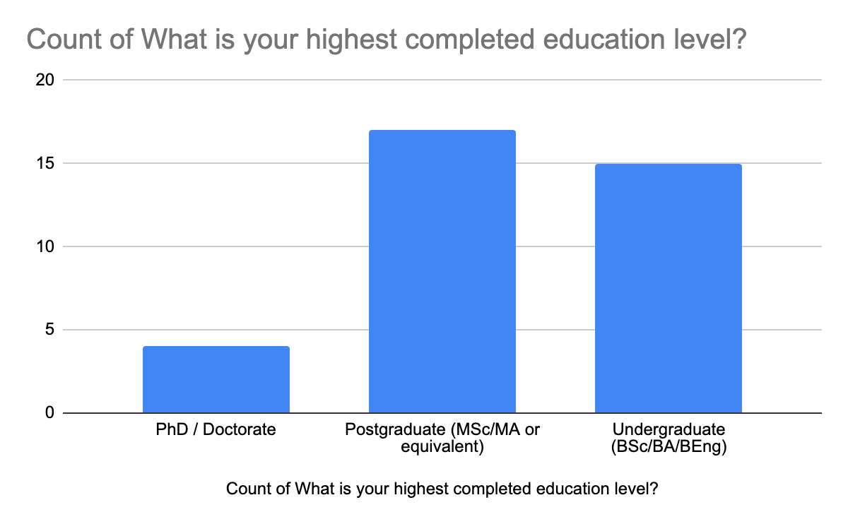
Most respondents were affiliated with universities, followed by research institutions and government laboratories. A smaller number represented private organizations and independent initiatives.
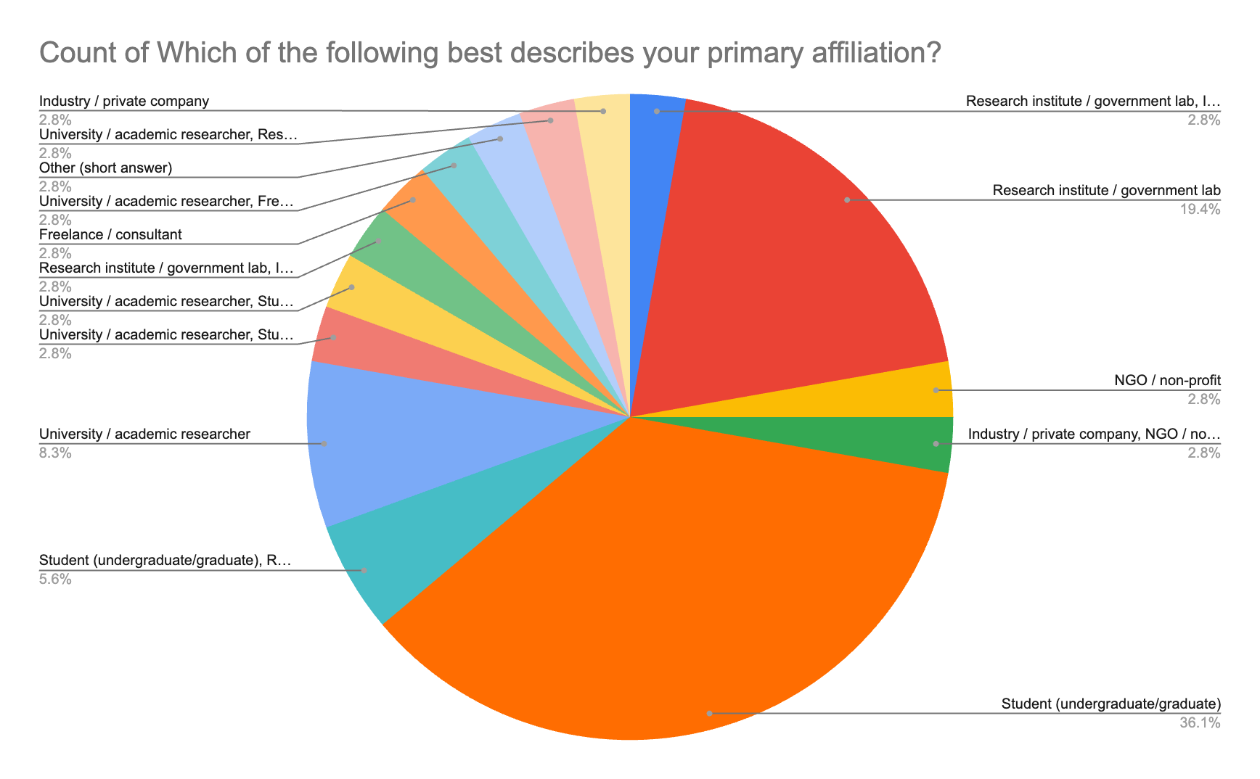

Employment status varied across participants:
- Full-time students formed the largest group
- Followed by unemployed job seekers
- Then full-time employees, freelancers, and volunteers
This distribution suggests that many respondents are in early career stages, where skill development and training opportunities are especially important.
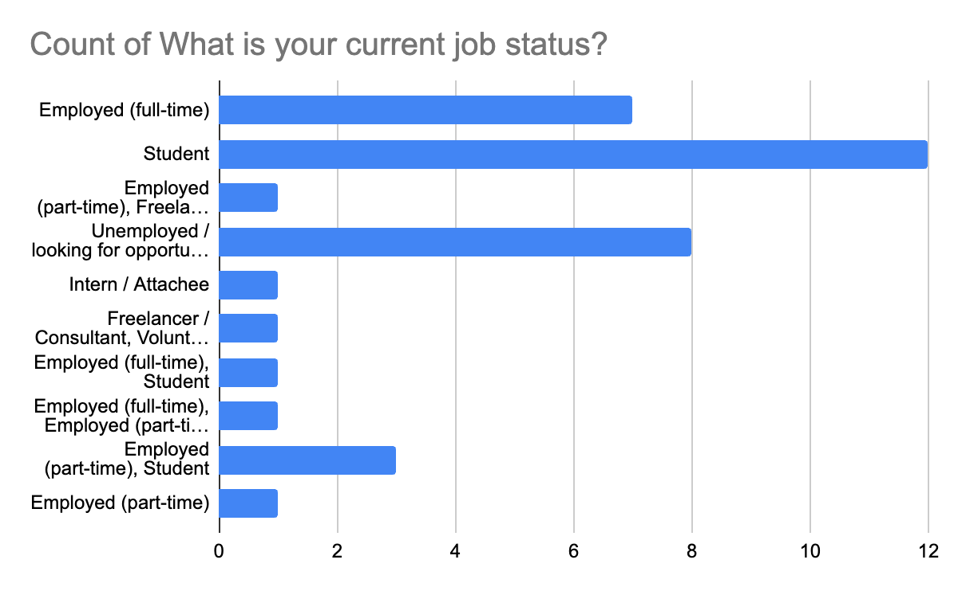

Open source software awareness
Most respondents reported familiarity with the concept of open-source software. However, a significant proportion were unsure whether they had actively used OSS tools. This suggests that while open source software is widely used in practice, awareness of licensing and development models may be limited.
This pattern is common in scientific computing, where researchers frequently rely on open source tools without necessarily recognizing them as such. Many widely used bioinformatics tools and programming environments are open source by default, making passive use far more common than active contribution.
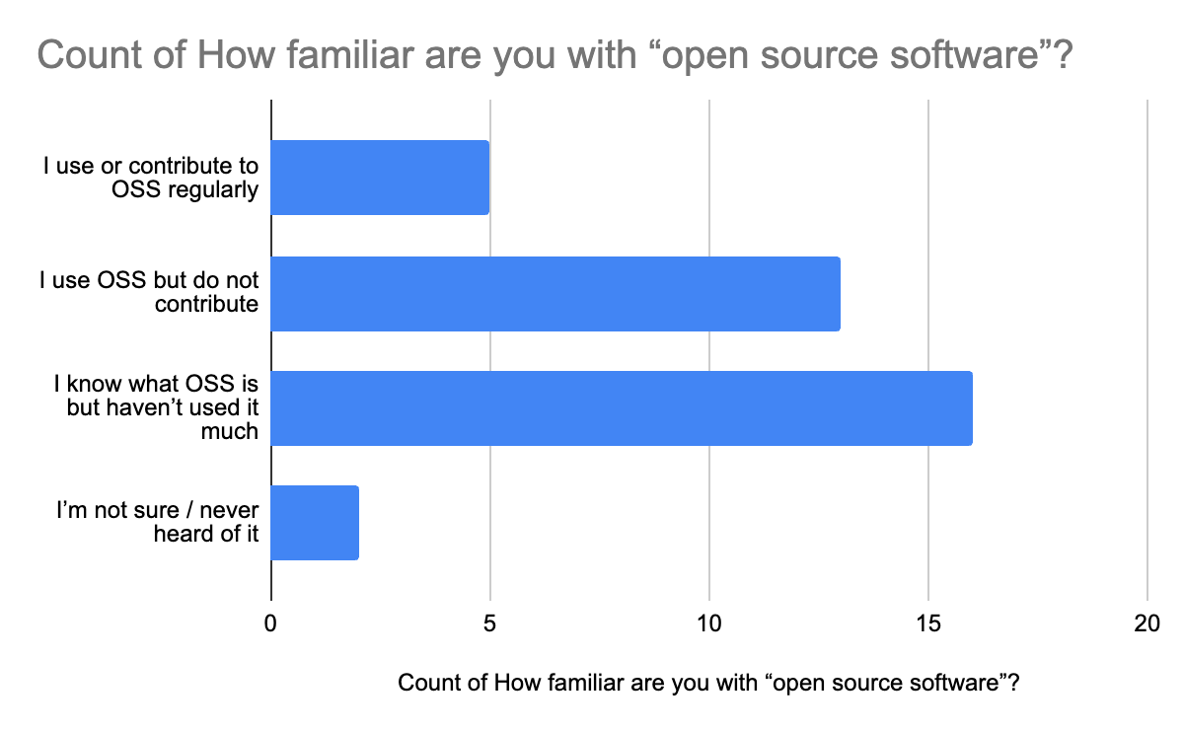

Programming experience
Respondents generally reported moderate to strong programming experience, with many indicating that they regularly write scripts as part of their academic or professional work. This suggests a solid technical foundation within the community.
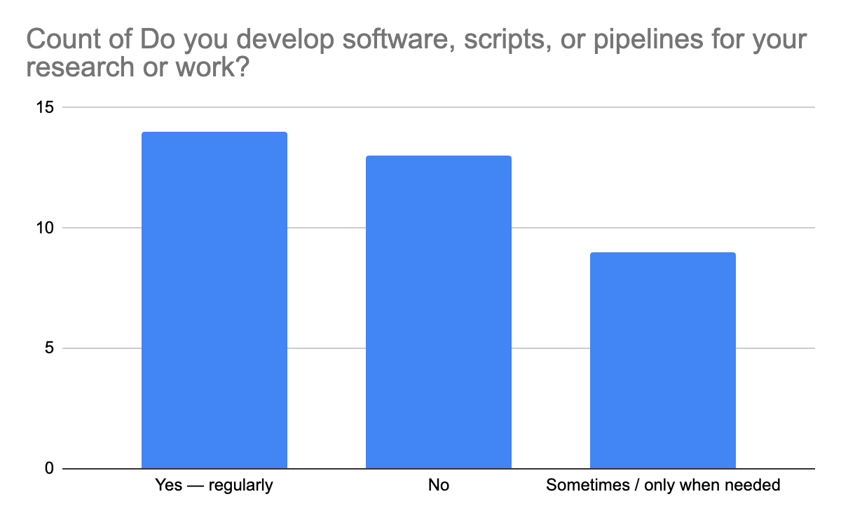

Commonly used programming languages included:
- R (most frequently used)
- Python
- Bash
- Java and SQL (less commonly)
The prominence of R and Python reflects their widespread use in bioinformatics and data science, where they support statistical analysis, visualization, and pipeline development.
Many respondents reported regular use of the command line, indicating familiarity with Unix-like computing environments commonly used in bioinformatics workflows. Awareness of code hosting platforms such as GitHub and GitLab was also widespread.
However, a subset of respondents identified as non-technical users and reported relying primarily on graphical user interface (GUI) tools. This highlights the importance of inclusive training pathways that accommodate varying levels of technical experience.

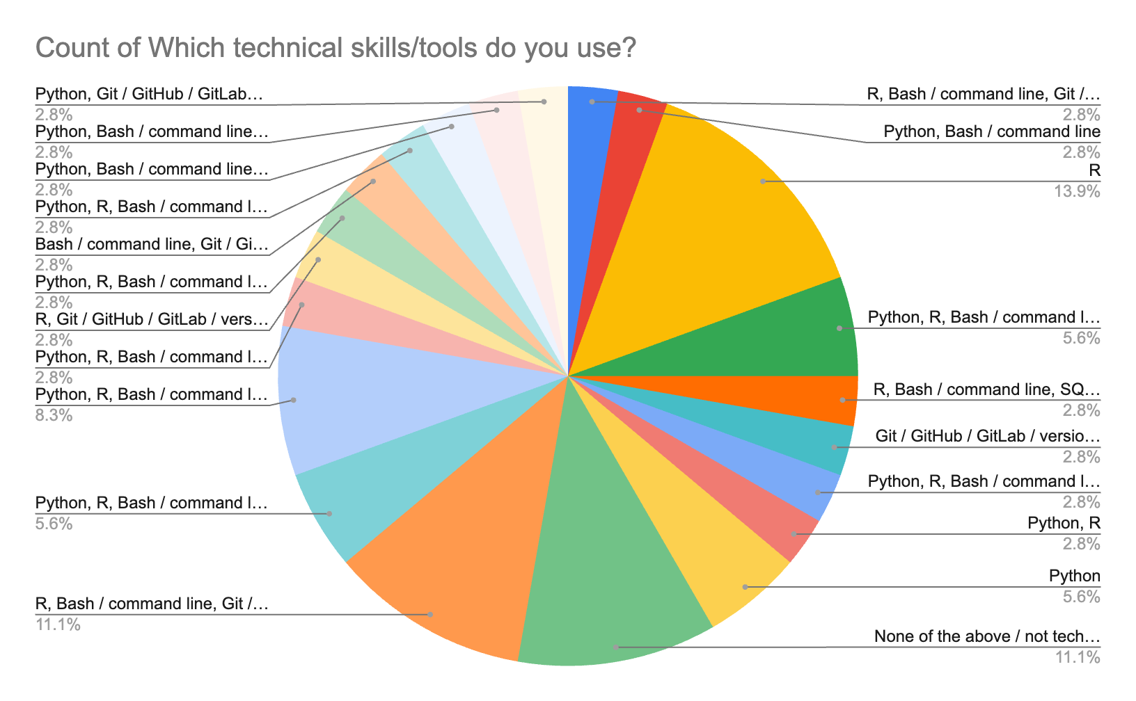

Confidence level
Despite relatively strong technical foundations, self-reported confidence levels averaged 2-3 on a 5-point scale. This indicates that many participants possess basic technical skills but lack confidence in applying them independently.
Low confidence is a commonly reported barrier in technical training environments and is often associated with limited opportunities for guided practice. Confidence tends to increase significantly when learners engage in real-world projects and receive feedback from experienced practitioners.

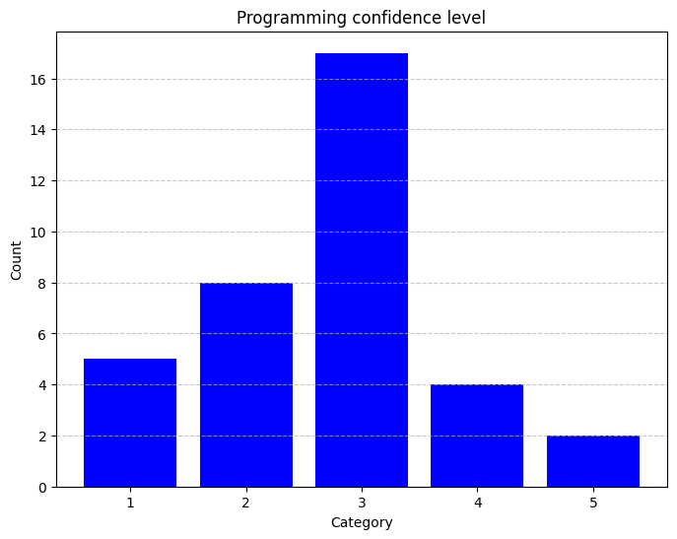

Interest in Contributing to OSS
Respondents expressed a strong interest in contributing to open source software projects. However, several barriers were identified that limit participation:
- Low confidence
- Fear of making mistakes
- Uncertainty about where to begin
- Difficulty identifying suitable projects
- Imposter syndrome
- Lack of mentorship
- Limited access to supportive communities
These findings align with broader research on OSS participation, which consistently identifies onboarding challenges and a lack of mentorship as major barriers for new contributors.
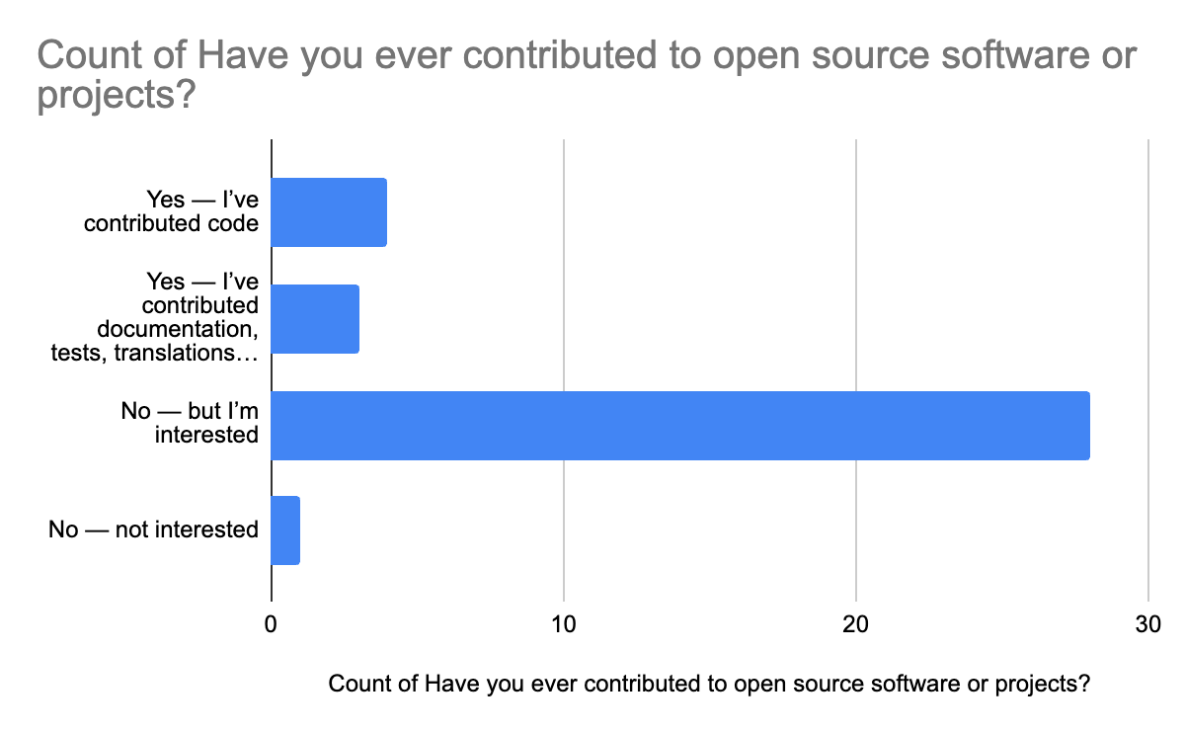

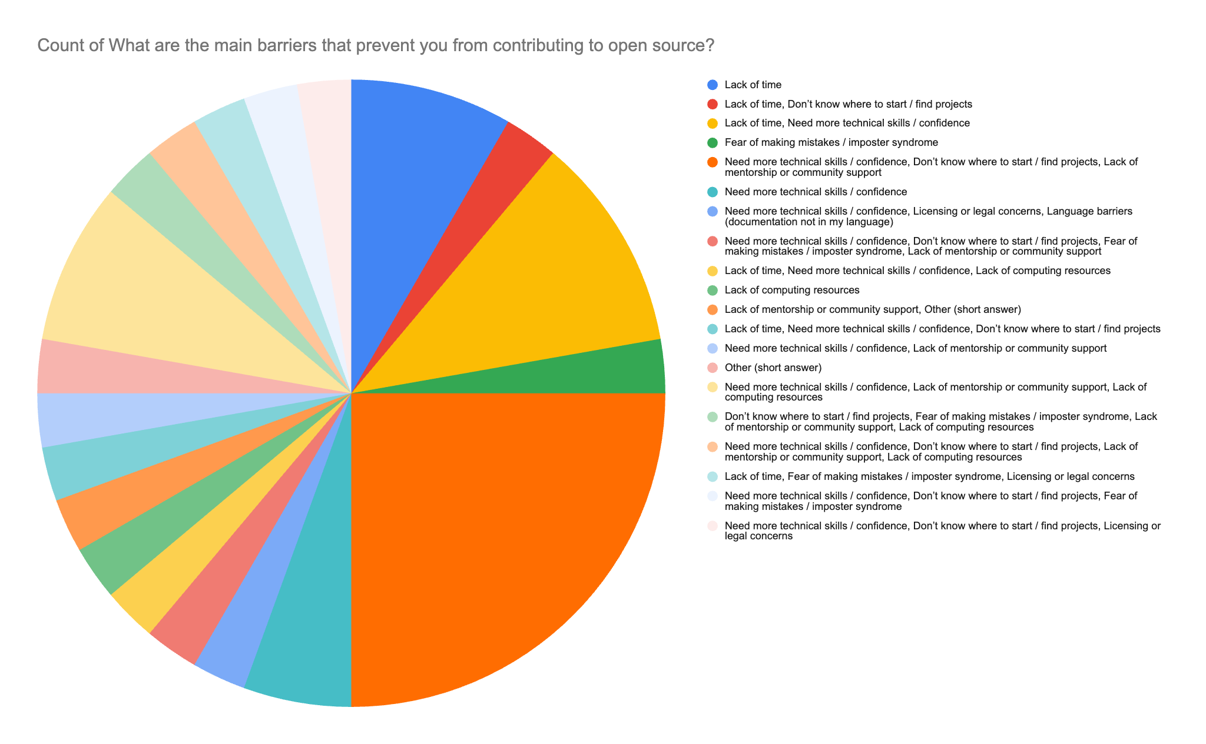
In many training environments, theoretical instruction is emphasized over project-based learning. As a result, learners may develop technical knowledge without gaining the practical experience needed to participate confidently in collaborative software development, especially if the software development is not a key part of research output.
So, what next?
Respondents expressed a strong desire to build both confidence and practical skills. They were especially interested in short-term, project‑based courses, such as building packages and pipelines. Practical, project‑driven learning would give them the space to experiment and grow their confidence through real experience.
Mentorship emerged as another critical need. Many students have never had the chance to work closely with software or pipeline maintainers, nor to observe how real OSS development happens. They lack access to environments where they can ask questions, express curiosity, and receive constructive feedback. A structured mentor–learner relationship would fill this gap and provide the guidance essential for growth.
Respondents also emphasized the importance of Git and GitHub training, from beginner to advanced levels, to strengthen foundational skills for contributing to OSS.
Finally, there was a strong interest in more hackathons and code sprints. These events offer ideal practice grounds—especially when paired with mentorship—because participants can try things out, receive immediate feedback, and build confidence through supported, hands‑on learning.
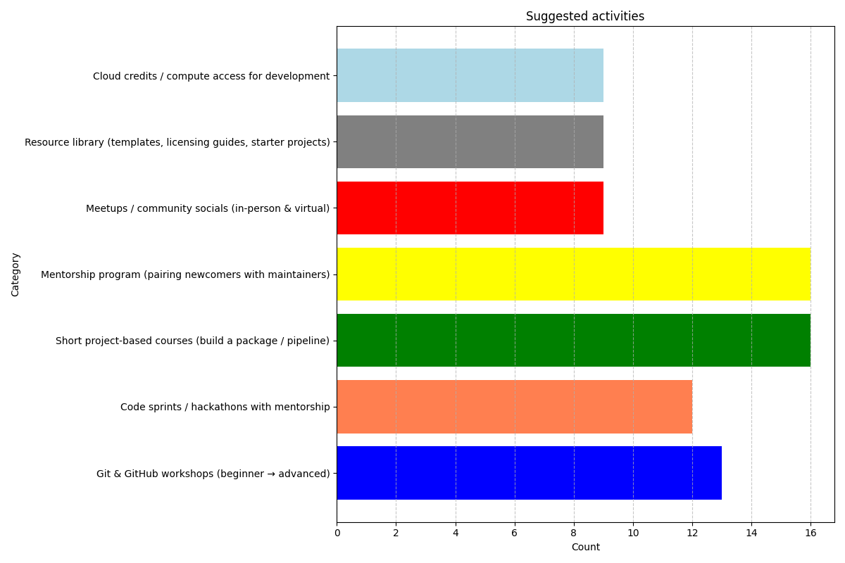

Call for Collaboration
The survey findings highlight significant opportunities to strengthen open source engagement within the bioinformatics community. Addressing these gaps will require coordinated efforts across institutions and organizations.
BHKi invites collaboration with open science communities, research groups, and industry partners to support the development of OSS capacity.
We invite collaborators to:
- Co-developing short-term OSS training programs
- Supporting hackathons and code sprints
- Providing mentorship and technical guidance
- Developing pipelines and packages suitable for new contributors
- Creating structured onboarding pathways for OSS participation
Through collaborative efforts, it is possible to build a stronger, more inclusive open-source ecosystem that supports both learning and innovation.

